**Lab: Measurement of the Earth’s Magnetic Field**

**Introduction**

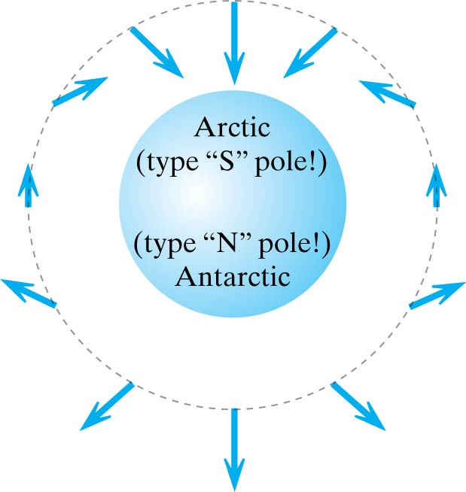The Earth’s magnetic field exhibits changes with time and is not uniform across the surface of the earth. It is not completely clear how the earth’s magnetic field is produced. The most widely accepted view is that its origins are in the earth’s core. The flow of the molten metals (mostly iron and nickel) generates electric currents that generates part of the earth’s magnetic field. Additionally, the solar winds from the sun ionize the ionosphere and this adds to the magnetic field.

Figure 1. A very simplistic sketch of the geomagnetic field. (image from Matter & Interaction by Chabay and Sherwood.

A simple model of the field is presented on Figure 1. In Figure 1 the secondary field due the solar winds is not shown. The field, nonetheless, starts somewhere near the geographic south pole and ends near the geographic the north pole indicating that the geomagnetic poles are not exactly aligned with the geographic poles. The earth’s magnetic field is, thus, nearly horizontal near the equator while it is nearly vertical near the poles. A compass placed on the surface of earth dips to align with the total field. In the northern hemisphere, the north-end of the compass directs downward at some inclination angle,  depending on its latitude. It is clear from Figure 2 that the total magnetic field of the earth, B, is related to the horizontal component of the field, BH, and the inclination angle by

(1)



North

BH

Horizontal Surface in the Northern Hemisphere

**

B

Figure 2: The relationship between the earth’s magnetic field B and the horizontal component BH at the earth’s surface in the northern hemisphere.

A simple apparatus for measuring the strength of the horizontal component of the earth’s magnetic field is a tangent galvanometer consisting of a small magnetic compass at the center of a circular coil of wire. A power supply provides an electric current that produces a magnetic field at the center of the coil where the compass is located as shown in Figure 3. This field is directed perpendicular to the plane of the coil. Its magnitude is given by

(2)



where N is the number of turns of wire in the coil, I is the current, and R is the radius of the coil.

With the plane of the coil aligned parallel to the earth’s magnetic field, the field of the coil Bcoil will be perpendicular to the direction of BH. The earth’s field BH tries to align the compass needle toward the north, while Bcoil tries to align it along the east-west line. The resultant orientation of the needle is somewhere between these directions depending on the relative strength of the two fields. The angle , shown in Figure 4, by which the needle is deflected away from the direction of BH gives a measure of the strength of the field Bcoil relative to the strength of the horizontal component of the earth’s magnetic field BH. In fact,

 (3)

Coil

DMM

Compass

10A

Com

- ve

Power Supply

+ ve

Figure 3: The experimental apparatus used to measure the horizontal component of the earth’s magnetic field.

By calculating Bcoil from the data and reading the deflection angle off the compass as illustrated in Figure 4, we obtain a value for BH. Combining this result with the inclination angle  according to Equation (1) gives the measured strength of the earth’s magnetic field at a given location.



BH

Bcoil

Figure 4: The deflection of the compass needle due to the magnetic field of the coil perpendicular to the horizontal component of the earth’s magnetic field.

**Pre-lab Exercise**

Derive Equation (2) for the magnitude of the magnetic field at the center of a circular coil of radius R with N turns due to a current I in the coil.

**Procedure**

1. Remove the compass from the apparatus, measure the radius R of the coil, and record the value with uncertainty on the data sheet.
2. Record the number of turns of wire N on the data sheet.
3. Place the compass at the center of the coil and align the vertical plane of the coil parallel to the compass orientation.
4. Without otherwise disturbing the apparatus, rotate the compass box until the ends of the compass needle are aligned with 0 and 180 on the compass scale.
5. Turn on the power supply, and adjust the current to a value around 0.5 A. (Use the external ammeter (DMM) to measure the current, not the meter on the power supply.) Record the current with uncertainty for trial 1 in Table 1 on the data sheet.
6. Read the deflection (in degrees) of each end of the compass needle. (Tap on the compass box lightly to make sure that the compass needle is not binding and moves freely.) Record the deflection of the north pole of the compass needle as N-left in Table 1. Include an estimated uncertainty in these values.
7. Reverse the direction of the current in the coil by flipping how the wires from the coil are connected to the power supply. Check the current and adjust it, if necessary, to the same value as in step 5. (Left and right currents should be exactly the same for each trial.)
8. Read the deflection (in degrees) of each end of the compass needle as in step 6. Record the value as N-right in Table 1.
9. Repeat steps 5-8 for four other values for the current between 0.2 and 0.8 A.
10. Use the dip compass to measure the inclination at five different locations in the room and record the values (with uncertainties) in Table 2 on the data sheet.

**Analysis**

1. For each trial, average the two measured deflection angles and record the result as  in Table 1.
2. Calculate and record the horizontal component of the earth’s magnetic field BH for each trial as described in the Introduction. Also determine and record the uncertainty for each value.
3. Calculate the average of the values you obtained for BH from the five trials and enter the result (with uncertainty) on the line provided on the data sheet.
4. Compare your value for BH with values from National observatory and comment on the agreement. (<http://www.ngdc.noaa.gov/geomag-web/#igrfwmm>)
5. Calculate and record the average Inclination angle  (with uncertainty).
6. Use your values for BH and  to calculate the strength of the earth’s magnetic field B at Schenectady and record your result (with uncertainty) in the space provided on the data sheet.
7. Compare your value for B with values from National observatory and comment on the agreement.

**Data**

Radius of the coil R = _____________; Number of turns of wire N = _____________

Table 1: Measurements of current and deflection angle used to determine the horizontal component of the earth’s magnetic field.

|  |  |  |  |  |  |
| --- | --- | --- | --- | --- | --- |
| Trial | I  (A) | N-left (degrees) | N-right (degrees) | (degrees) | BH  (T) |
| 1 |  |  |  |  |  |
| 2 |  |  |  |  |  |
| 3 |  |  |  |  |  |
| 4 |  |  |  |  |  |
| 5 |  |  |  |  |  |

Average value of BH = _________________________

Table 2: Measurement of the inclination using a dip compass

|  |  |  |
| --- | --- | --- |
| Trial | Inclination  (degrees) | Comment |
| 1 |  |  |
| 2 |  |  |
| 3 |  |  |
| 4 |  |  |
| 5 |  |  |

Average value for the inclination  = ____________________________

Average value for the earth’s magnetic field at Schenectady B = _____________________________

Write an abstract and results. Please read the guideline on how to write these posted on Nexus. Also attach this handout.