Union College Spring 2019
Physics 121

Your Name ______________________________________ lab partner: __________________________________

Honor Code Pledge:

I affirm that I have carried out my academic endeavors with full academic honesty

Signature: _______________________________________________ Date:__________________

Lab #3: Resistors in parallel, series, and mixed circuit
Introduction:
In our first lab we used multi-meters to measure the voltage across and the current through a single carbon resistor. From these measurements we determined the resistance and verified whether it was ohmic in the range of voltages in our experiment. In this lab we again use multi-meters to measure the voltages and currents, but now in a circuit made up of three resistors.

Objective:
We will determine how voltages and currents vary in three different circuits. In the first experiment we connect three resistors R₁ = 220 Ω, R₂ = 330 Ω, and R₁ = 470 Ω in series to our power supply. We then measure the current through each resistor and the voltage across it to inquire how voltages and currents behave in a series circuit. In the second experiment we connect these three resistors in parallel and again make current and voltage measurements for each. In our third experiment we connect two of the resistors in parallel and connect this in series to the third resistor and again measure the currents and the voltages.

Experiment #1 –resistors in series:
Connect your three resistors in series (i.e., so that there is only one path for the mobile charges to follow) to the power supply, as depicted in Figure 1.
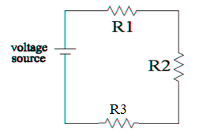
Figure 1: Schematic of circuit with resistors connected in series.
Connect two DMMs to measure the current through and voltage across R1 and measure ΔV _{R1} and I_{R1} for five different power supply voltages. Then do the same for the other two resistors using the same power supply settings. Finally, measure the total ΔV across all the resistors and the total I for the same five power supply voltages.
On a single graph, plot ΔV_{R1} vs I_{R1}, ΔV_{R2} vs I_{R2}, ΔV_{R3} vs I_{R3} and ΔV_{total} vs I_{total} and label each curve. Fit a straight line and do regression analyses to find the resistance with uncertainty of each resistor and the equivalent (total) resistance of the circuit.

 | R₁ | R₂ | R₃ | R_{equivalent}
R ± δR

Briefly describe the behavior of voltages and the currents in a series circuit:

Experiment #2 – parallel resistors:
Connect your three resistors in parallel (i.e., so that each resistor is a different path the charges can take) to the power supply, as depicted in Figure 2.
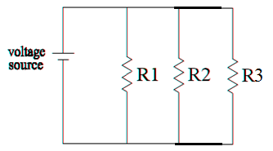
Figure 2: Schematic of circuit with resistors connected in parallel.
As in experiment 1, measure ΔV _{R1} and I_{R1} for five different power supply voltages and then do the same for the other two resistors and for the total circuit (all using the same five power supply voltages).
On another single graph, plot ΔV_{R1} vs I_{R1}, ΔV_{R2} vs I_{R2}, ΔV_{R3} vs I_{R3} and ΔV_{total} vs I_{total} and label each curve. Fit a straight line and do regression analyses to find the resistance with uncertainty of each resistor and the equivalent (total) resistance of the circuit.

 | R₁ | R₂ | R₃ | R_{equivalent}
R ± δR

Briefly describe the behavior of voltages and the currents in a parallel circuit:

Experiment #3 – mixed circuit:
For this part connect R₁ and R₂ in parallel and then connect them in series to R₃, as depicted.
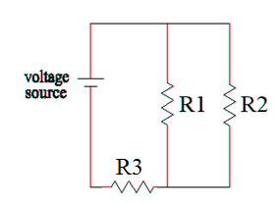
Figure 3: Schematic of a mixed circuit with two resistors in parallel, and in series with a third.
Prediction: Based on the results of the experiments 1 and 2, what do you expect qualitatively of the currents and voltages through each resistor? What do you expect of the equivalent resistance of the total circuit?

For a single ΔV on the power supply measure ΔV across each resistor, the current exiting it, the total ΔV across all the resistors and the current exiting the power supply.

Briefly describe the behavior of voltages and the currents in this mixed circuit:

