Homework for “Finding the Temperature of a Light Bulb Filament” Lab

Name ____________________________
D
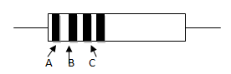
1a) A certain resistor has colored stripes, as shown. What is the resistance value with percent tolerance?

Resistance _____________ +/- _________ %
A – blue
B – green
C – orange
D -- gold

What range of resistances is consistent with this color code?

__________ < R < ____________

b) Three resistors have the color codes shown in the table. Unfortunately, each resistor has had one of its stripes worn off (indicated by an X in the table). Which of the three resistors is the largest? Circle 1, 2, or 3.

 | A | B | C | D
1 | X | Red | Green | silver
2 | Red | X | Red | silver
3 | Blue | Red | Brown | X

2. Instead of placing the multimeter where we did in lab to measure current, we could have placed it as shown at right. This figure should be compared with figure 3 of the lab handout. Write an explanation of why an ammeter placed as shown in the diagram will correctly read the current through the light bulb and the resistor.
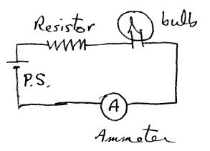

3. The graph below show the voltage across a certain resistor as a function of the current through it. A best fit line has the formula y = 4.5 x. What is the approximate resistance of this resistor? Carefully note the units on the axes.

Approximate resistance in Ohms _____________________

Is this resistor ohmic? Explain how you know.

(Circle one) yes no
Explain

4. In the circuit below, the ammeter has a positive reading. Circle the arrows that indicate the direction of the current through the two resistors.
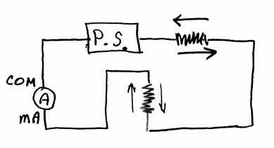

5. A 1.00-m length of tungsten wire has a resistance is 0.32 $Ω$? [You may use the table of resistivities from your lab handout.] Find the cross-sectional area of the wire and the diameter of the wire in mm. Show your work.

Ans. Area ____________________ Diameter _____________________ mm

6. The variation of electrical resistance with temperature can be used to make precise temperature measurements. Platinum is commonly used since it is relatively free from corrosive effects and has a high melting point. The temperature coefficient of resistance for Platinum is 0.00393/⁰C. Suppose that at 20.0 ºC the resistance of a platinum resistance thermometer is 164.2 $Ω$. When placed in a particular solution, the resistance is 187.4 $Ω$. What is the temperature of the solution? Show your work.

Ans. ____________________

