Stephan-Boltzmann Law 1
Physics 123 Laboratory, R. Koopmann

Lab: Stephan-Boltzmann Law
Introduction
The Stefan-Boltzmann Law relates the flux, F, the power per unit area, radiated by an object to T, the absolute temperature of the object. The equation is:
(1)

where dQ is the energy transferred in dt time interval over the surface area A, and P is power, e is the emissivity, and σ = 5.6703 x 10⁻⁸Wm⁻²K⁻⁴. In this experiment, you will make relative measurements of the power per unit area emitted from a hot object, namely the Stefan-Boltzmann Lamp filament, at various temperatures. The temperature of the tungsten filament is correlated to its resistivity. You will measure the resistance of the filament and convert to temperature using a known correlation. The relative power per unit area emitted will be measured using a radiation sensor. We will assume that e=1 for the tungsten filament.

Experiment
You cannot measure the resistance of the filament directly, so you will instead compute the resistance by considering the voltage and current running through the filament. Important: The voltage into the lamp should NEVER exceed 13 V. Higher voltages will burn out the filament!

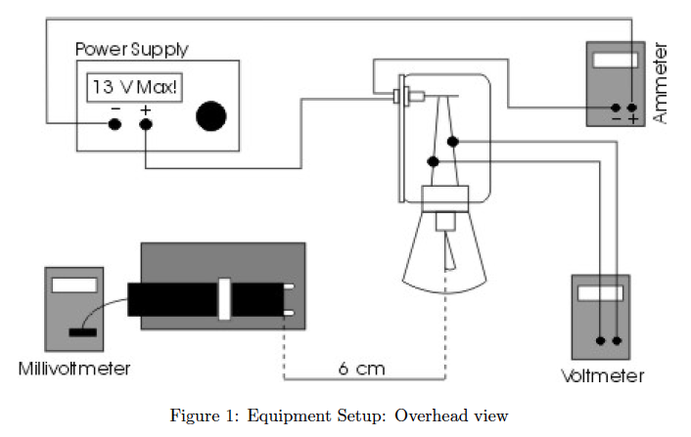
- Set up the equipment as shown in the Figures 1 and 2. The voltmeter should be connected directly to the binding posts of the Stefan-Boltzmann lamp. The sensor should be at the same height as the filament, with the front face of the sensor approximately 6 cm away from the filament. The entrance angle of the thermopile should include no close objects other than the lamp. Be careful with the alignment - it will improve your results.
- Before beginning, have your instructor check your setup.

Part I: Temperature dependence

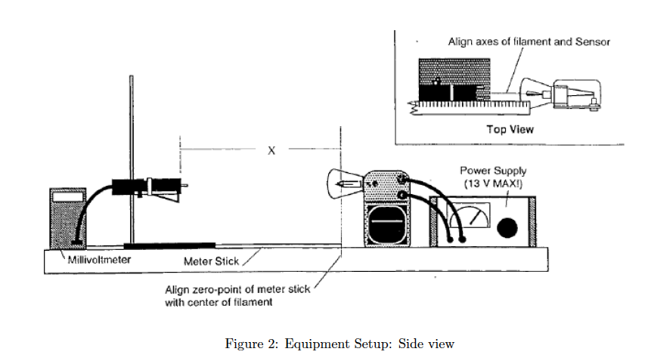
- Turn on the power supply. Set the voltage, V, to approximately 1 Volt. Record the actual V, the current, I, (the ammeter reading), and Rad, the reading on the millivoltmeter. IMPORTANT: Make the Rad reading quickly. While not measuring, place both sheets of insulating foam between the lamp and the sensor, with the silvered surface facing the lamp, so that the temperature of the sensor stays relatively constant. Estimate the uncertainties in your measurements (although you will not propagate these uncertainties.)

- Repeat instructions in (4) 11 times, increasing the voltage about 1-volt each time, to a maximum 12-volts.

- Lower the voltage to zero and allow the filament and radiation sensor to cool down for 5 minutes.

Part II: Distance dependence: You need to do this relatively quickly. The separation distance does not need to be exactly as what is outlined in the procedure. You just need to keep track of it.

- Move the sensor close to the filament so that x is approximately 2cm in Fig. 2. Adjust the voltage in the power supply to about 5V. Leave this fixed from here on but keep an eye on the current and record it. If it changes, record also the new value.
- Take a measurement and place the insulating board in front of the radiation sensor.
- Repeat the above step for separation distances approximately 4, 6, 8, 10, 12, 14, 16, 18 and 20 cm.

Analysis

Part I: Temperature dependence
- Enter your voltage and current data into a spreadsheet. Compute the resistance of the lamp for each voltage.
- The temperature of the filament is correlated with the relative resistivity of the tungsten, i.e., the resistance normalized by the resistance at room temperature. You will use a calibrated transformation between your measured resistances and temperature. To do this, use the following procedure:
  - Divide your calculated resistances by the first resistance at 1 V (reference voltage). This will give you R/Rref.
  - Next, use equation (2) to convert the resistance ratio (R/Rref) into temperature (T) in kelvin.

(2)

- You now have values of T and the power radiated in your worksheet. If you plot these, what type of graph do you get?
- It is often easier to analyze a linear plot. Determine what you should plot in order to obtain a linear plot. You need to choose a form that will allow you to predict the value of the slope. What slope do you expect, using your form? What does the y-intercept represent? Can you compare either of these values to something you know?
- Calculate the quantities you need to create a linear plot and create the plot. Make a linear fit to the data and determine the slope and y-intercept with errors. Does the expected slope lie within the measured slope with uncertainty?
- Experiment with fitting lines to different ranges in the data, and measure the slopes in each range. Does the slope fit match better over a more limited region in the graph?

Part II: Distance dependence
- Assume that the out of the source is constant. This is why you kept the voltage at a fixed value. However, the sensor will pick different amount of flux.
- Find the relationship between the measured flux and the distance between the source and the sensor.

Writeup

Write a brief results and discussion. Be sure to include and refer to your graphs. You need not propagate any measurement uncertainties - judge the error in your result from the errors to the linear fit.

Hint: In your discussion, address systematic effects that might influence the slope. Consider the following questions:
- What sources of thermal radiation, other than the lamp filament, might have influenced your measurements? What effect might they have had and would the effect be systematically worse at particular V’s?
- Are there any systematic effects which might influence the measurement of thermal radiation by the radiation sensor?
- Another source of error is that e = 1 is only true for ideal (blackbody) radiators, i.e., an object that absorbs all the radiation which strikes it. Does the lamp filament absorb all the radiation which strikes it? At high temperatures, this effect should be negligible. Why?

