Union College Spring 2021
Physics 120
Lab 7: Measuring Rotational Inertia Using the Energy Principle

In this experiment you will empirically measure the rotational inertia of a body by applying energy principles to a rotating turntable connected to a falling mass.

Apparatus:
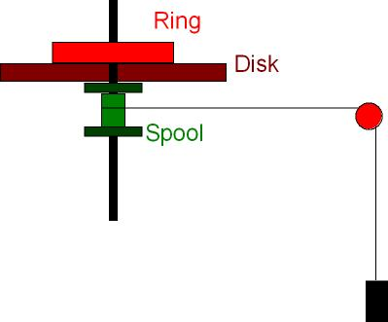
The figure shows a cross sectional sketch of the apparatus. A hanging mass, m_{hanging}, is connected to a rotating apparatus by a string that passes over a pulley. The pulley is connected to the computer so that the Capstone software can be used to infer the speed of the string passing over the pulley. The other end of the string is wound around a spool, of radius r, that is coaxial with a large disk and rotational apparatus. As the mass falls, it pulls the string, which causes the disk to spin. By using conservation of energy and measuring the speed of the string and the height the mass fell, we will infer the rotational inertia of the rotating objects. We will then use this apparatus to empirically measure the rotational inertia of a complex object placed onto the disk.

Pre-lab Calculation:
In the experiment, the entire system will start from rest and the mass will fall a height Δy and obtain a final speed v_{f}. The spool has radius r_{spool}, and the rotational apparatus has rotational inertia I. Assuming no energy dissipation due to friction or air resistance, and neglecting the kinetic energy in the string and pulley, use conservation of energy to derive an expression for the rotational inertia, I, of the rotational apparatus in terms of m_{hanging}, Δy, v_{f}, and r_{spool}.

Data Collection
1. Use the Vernier calipers to measure the diameter of the rotator spool (the part of the rotator that the string wraps around) and record the radius, r_{spool} (with appropriate uncertainty).
2. Open “Pasco Capstone.” Click on “hardware setup” in the upper left and then click on port ‘1’ and select “photogate with pulley.” Click on “hardware setup” again and then drag two graphs into the central area. In each graph click on the y-axis label — in one select “position” and in the other select “linear speed”.
3. Make sure that the large gray disk on the rotating apparatus has no other object on top of it.
4. Hang a 50-g mass from the string and make sure that the string passes over the pulley and that the smart pulley is oriented at the right angle for the string to pass over the pulley directly.
5. Wind the string around the spool by turning the rotator until the mass is a cm from the pulley.
6. Click “Start” in Capstone and release the rotator.
7. Click “Stop” before the mass hits the ground. Also, be sure to stop and catch the wheel to prevent the string from winding around the other side of the spool.
8. From the graphs, using the “delta tool,” obtain the final velocity and change in height of the falling mass. Make sure that your final velocity matches up in time with your final position.
9. Repeat for hanging masses of 100, 150, 200, 250, and 300 g.
10. Add the hollow black ring to the rotating system and repeat with all the same masses.
12. Measure, the mass, M_{ring,} the inner radius, R₁, and the outer radius, R₂, of the ring, including estimates of the uncertainties.
13. On the rotating system, replace the disk with the disk holding the sculpture, hang the 0.100-kg mass, and repeat steps 8-11. Make just one measurement with the sculpture.

Analysis:
1. Use your equation to calculate the rotational inertia of the rotating system for each trial.
2. Subtract I_{disk only} from I_{disk+ring} to get I_{ring} for each value of m_{hanging}.
3. Calculate the average and standard error for I_{ring}.
4. Using the measurements of M_{ring}, R₁, and R₂ calculate the expected rotational inertia of the ring, as given by $=\frac{1}{2}M(R_{1}^{2}+R_{2}^{2})$.
5. Do the experimental and theoretical values for the rotational inertia agree to within the uncertainties?
6. Using just one measurement, calculate the rotational inertia of the metal sculpture. For the uncertainty, assume that the standard deviation will have the same percentage as with the black ring and since you made only one measurement, the standard deviation will equal your standard error (i.e. uncertainty).

