Union College Spring 2014
Physics 121
Lab #5: Using Digital Multi-meters, Ohm’s Law for Resistance, and Confirmation of the Node and Loop Rules

Analysis of circuits requires use of the two Kirchhoff’s rules -- the node rule and the loop rule – and the definition of resistance for a circuit element given by Ohm’s law, i.e. ΔV = IR,
where ΔV is the change in potential (or voltage drop) across the element (in volts), I is the current through the element (in amperes), and R is the resistance of the element (in ohms).

In this lab, we will measure changes in potential, currents, and resistances in a few simple circuits to test these principles. All of these quantities can be measured with one device called the “digital multi-meter,” or DMM.

IMPORTANT: IF YOU CONNECT THE DMM TO A CIRCUIT INCORRECTLY WHEN THE DIAL IS SET TO READ AMPS (OR mAMPS) YOU WILL BLOW A FUSE INSIDE THE DMM. TO AVOID BLOWING A FUSE, KEEP THE DMM DIAL AWAY FROM THE AMPS AND mAMPS SETTINGS, AND WHEN YOU WANT TO MEASURE CURRENT, DO NOT TURN THE DMM TO AMPS UNTIL AFTER IT IS HOOKED UP PROPERLY AND, WHEN DONE WITH THE CURRENT MEASUREMENT, FIRST TURN THE DIAL AWAY FROM AMPS BEFORE DOING ANYTHING ELSE.

Using the DMM:
1. Measuring Current: Current is the amount of charge passing any specific point per second and so a measurement of current must occur at a single location in the circuit. This can be done by “breaking” the circuit and inserting the ammeter in series. The current, then, will flow through the ammeter. In order for the insertion of the ammeter to have no effect on the circuit, it must have negligible resistance. (Therefore, a very large current in the ammeter can result which could damage the internal circuit. To prevent this from happening a fuse is installed which will blow (and stop the current) if the current gets too large. Hence, the reason for the warning above.) Before turning the DMM dial to A or mA, be sure that the current that will go through the DMM must also pass through some reasonable resistance. If the DMM is hooked up in series with a resistor, there should be no problem.
To get the right sign of the current, the COM terminal should be connected to the “negative” wire (i.e. the wire leading to the negative terminal in the power supply) and the “A” or “mA” terminal to the positive wire. See Figure 1.
2. Measuring Voltage: Since voltage is a CHANGE in potential, this measurement requires connecting the DMM to the circuit at two different locations. To measure the ΔV across an individual element, for example, one connects the voltmeter in parallel with the circuit element, as shown in Figure 1. In order for a voltmeter to not alter the circuit, it must have an extremely large resistance, so that none of the current, effectively, runs through the voltmeter instead of the circuit element. If you hook a voltmeter in series, it will significantly impede the current.
To get the right sign of the ΔV, connect the COM terminal to the “negative” wire and the “V” terminal to the positive wire.
3. Measuring Resistance: This measurement also requires connecting the leads from the DMM to two different places, usually at opposite ends of the circuit element of interest. This measurement does not require a complete circuit, and can be made on any device outside the circuit as well. This measurement is convenient for discovering where a break or a short in a circuit is located.

Figure 1: Proper connections for an Ammeter and a Voltmeter. Note that the Ammeter is connected in series with the resistor. If it were connected in parallel, then all the current would run through the meter (instead of the resistor) and blow the fuse.

Procedure:
IMPORTANT: Before turning on the power supply, for each new circuit, ask your instructor to check your circuit connections!!

For the following circuits, use the resistors labeled as R₁ = 220 Ω, R₂ = 330 Ω, and R₃ = 470 Ω. (You should still measure the resistances when instructed since it is easy to do and one should never assume the labels to be 100% accurate).

1. Use the DMM to measure the resistance of each of the resistors, and enter the values in the data table, attached at the end.

2. A simple single-resistor circuit. Make a circuit containing only the voltage supply and resistor R₁. Place a voltmeter across the power supply (remember to be sure that the DMM is NOT set to amps!) and adjust the supply to 10 volts. Measure the voltage drop across R₁. Does the loop rule work? Measure the current (BE SURE TO CONNECT DMM IN SERIES) and calculate the resistance of the resistor. Does Ohm’s law work?

3. A Simple Series Circuit – Turn off the power and add R₂ to the circuit as shown in Figure 2. Return the power supply to 10 volts. Measure the voltage across R₁ and R₂. Measure the current at three places in the circuit: immediately after the supply, after R_{1,} and after R₂.
(a) Calculate the resistances of each resistor using Ohm’s Law.
(b) Are your measurements in agreement with the loop and node rules?
(c) Measure the voltage drop across both resistors and use this value along with I_{supply} to calculate the equivalent resistance of the pair of resistors in series. How does the equivalent resistance of the pair compare to the individual resistances?

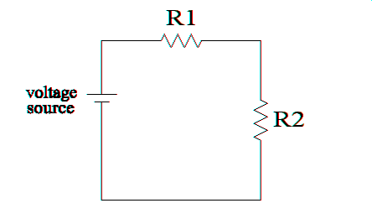
Figure 2: Schematic of a simple series circuit.

4. A Simple Parallel Circuit: - Turnoff the power and assemble the circuit of Figure 3. Adjust the power supply back to 10 volts. Measure the voltages across each resistor and across the power supply. Measure the current just after the power supply, and on each of the parallel paths.
(a) Use Ohm’s law to calculate the resistance of each resistor? Does this still work?
(b) Analyze your measurements with regards to the node and loop rules? Do they agree? Discuss. Note: there are two nodes and three loops to consider.
(c) Measure the voltage drop across both resistors and use this value along with I_{supply} to calculate the equivalent resistance of the pair of resistors connected in parallel. Compare your calculated value to the individual resistances. Do the pair in parallel have a larger or smaller equivalent resistance than either resistor by itself? Use the DMM to measure the resistance across both resistors. Does your measured value agree with your calculated value?
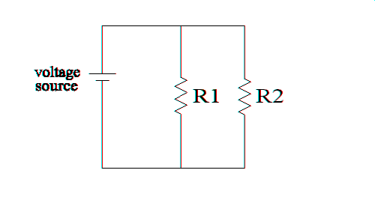
Figure 3: A simple parallel circuit.

(d) The expression for the effective resistance of parallel connections is given by:
.
Test this equation with your measurements. Does this work?

Data, Calculations, and Conclusions:

1. Resistances of Resistors:

R1 = ________±________ R2 = ________±________ R3 = ________±________

2. Single Resistor Circuit:

ΔV= ________±________

Does loop rule work?

I = ________±________

R_{calculated} =

Agree with R_{measured}?

Does Ohm’s law work?

3. Series circuit:
ΔV_{power supply} | ΔV₁ | ΔV₂ | I₁ (Out of Supply) | I₁(out of R₁) | I₂(out of R₂)

(a) Calculated Resistances According to Ohm’s Law:

R₁ = ΔV₁/I₁ =

R₂ = ΔV₂/I₂ =

(b) Agreement with the loop and node rules?

(c) ΔV across both resistors = ________±________

R_{equiv} =

Relation to the individual Rs?

4. Parallel Circuit:

ΔV_{power supply} | ΔV₁ | ΔV₂ | I_{power supply} | I₁ (through R₁) | I₂(through R₂)

(a) R₁ = ΔV₁/I₁ =

R₂ = ΔV₂/I₂ =

Agree with measured values?

Confirmation of Ohm’s Law?

(b) Test of node and loop rules:

(b) ΔV across both resistors = ________±________

R_{equiv} =

Relation to the individual Rs?

R_{equiv}(measured) = ________±________

Agree?

(d) R_{equiv}(equation) =

Agree?

