Union College Spring 2021
Physics 120: Lab 2

The Nature of Errors and Uncertainties in Measurements of Launch Speed

In this lab, you will use a spring-powered projectile launcher to fire a small metal ball upward. You will use two different experimental methods to determine the initial speed of the ball: measuring the maximum height that the ball reaches and measuring the total time that the ball spends in the air. Later in the week, you will then determine which measurement method is more accurate by measuring how far the ball travels when launched horizontally from the table top.

The real purpose of this lab, though, is for you to learn about the important experimental science issue of errors and uncertainties.

Types of Error:
There are two different types of errors that may creep into any measurement you make. It is extremely important when you do an experiment to be aware of all sources of error and which type of error they produce. The two types are:

Random Error: Random errors are present in any measurement and occur as natural variations in the measurement. When measuring the length of an object, for example, you will get slightly different lengths from one measurement to another. Although these errors can never be completely eliminated, their effect can be reduced by averaging many measurements together.

Systematic Error: Systematic errors, on the other hand, always cause a measurement to be in error in the same direction. For example, if you measured the length of an object with a meter stick that was marked incorrectly with the gradations being too close together, then all your measurements will yield numbers larger than the actual length. These errors are NOT reduced by averaging and must be removed entirely by altering the measurement method. If it is not possible to completely remove them, they must be carefully quantified and corrected for in the results.

Uncertainties:
After all the systematic errors have been removed (or at least corrected for), the final measurement will still have limited accuracy due to the presence of random errors. Thus there is some uncertainty in every measurement you make, and this uncertainty must be reported in your measurement.

Estimated: In many cases the uncertainty is an estimate of how accurate you believe your measurement is, and usually results from your ability to read a scale. For instance, if you are measuring an object, and it falls between the 3 and 4 mm mark of a ruler, you might guess that the length is 3.5 mm. However, depending on your ability to subdivide accurately between marks, you may think it could be 3.8 mm or 3.2 mm. In this case the uncertainty is ±0.3mm.
Calculated: If, however, you are able to make a number of measurements, not only can you improve the accuracy by averaging the measurements, you can also use the variation apparent in the measurements to calculate the size of the random errors. The standard deviation, which is usually assigned the symbol σ (lowercase Greek letter sigma), is considered a statistical measure of the amount of deviation from the average per measurement. The value of the standard deviation is such that there is a 2/3 probability that any single measurement we make will fall within a range of ±σ from the average value. The uncertainty for an averaged value is given by a quantity known as the “standard error,” which is equal to the standard deviation divided by the square root of the number of measurements, N:
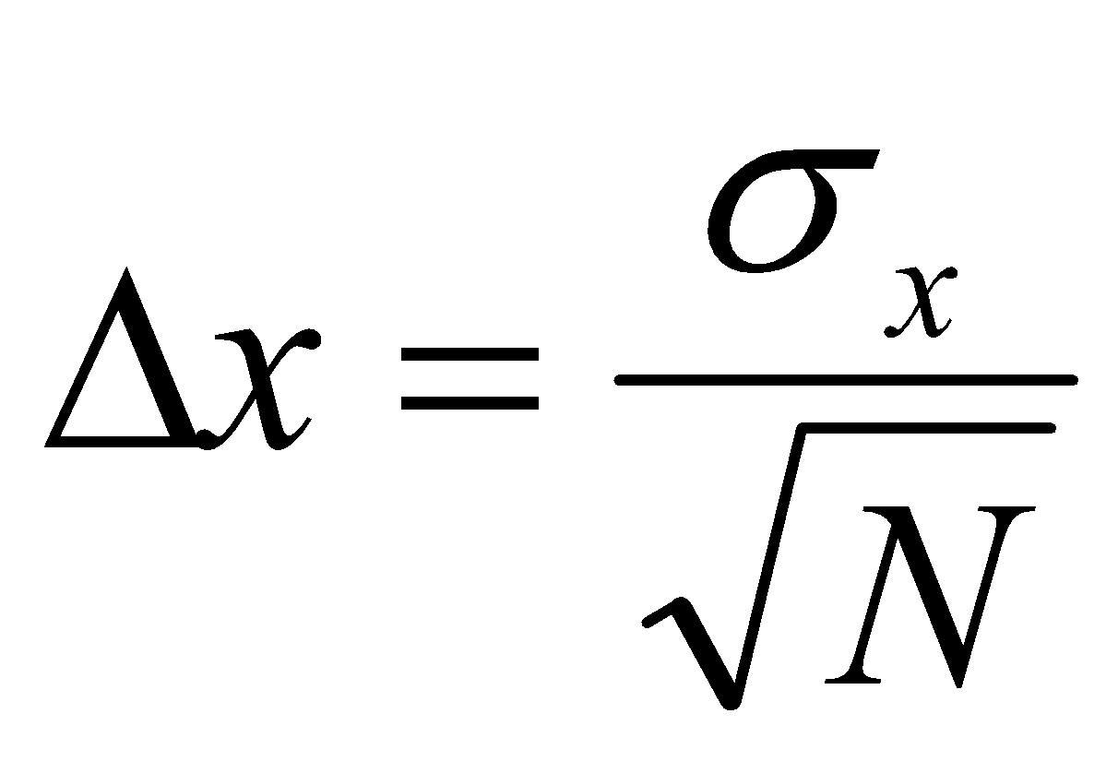
This is an extremely important equation for experiments!

Propagation of Uncertainty: When the desired result involves a calculation based on the measurements and you get to make the calculation only once, you will need to propagate the uncertainties in the measurements to the final calculated value. There is a mathematical process, based on derivatives of the equation, for doing this. In general, if the desired quantity is y, and it depends on two measurable variables, x and z, so that y = f(x,y), and x and y have errors given as Δx and Δz, respectively, which are completely independent of each other, then the uncertainty in y is given by
.

Reporting Results and Significant Figures: When you report your quantitative results, you must always list both your best measured value along with the uncertainty. For example, if the average of your length measurements is 2.035795 m, and the uncertainty is 0.004873 m, you should report your result in the format: “2.036 ± 0.005 m.” Note that the number of significant figures in the measured quantity stops at the decimal place of the uncertainty value. Note, also, that the units can be put at the end. This tells the reader that the best estimate of the measured value is 2.036 but it is likely to be anywhere between 2.041 and 2.031.

For the remainder of this lab, and the rest of Physics 120, you will be required to report uncertainties of every value that you measure, as well as use the standard error as a measurement of uncertainty.

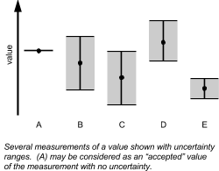
Finally, it is important to take uncertainties into account when comparing results. When comparing an experimental result to a known quantity with little or no uncertainty, then you need to note whether or not the known value falls within the range of uncertainty of your measured result. If it does (such as measurements (A) and (B) in the figure), then you can confidently claim that there is good agreement between the two quantities. For comparison of two values, each with their own uncertainties, things can be slightly more complicated. In the figure on the right, the best measurements in (B) and (C) each fall within the range of uncertainty of the other and so these are clearly in agreement. Consider the measured values (C) and (D)--do these agree with each other? Each best value is outside the range of uncertainties of the other, BUT the uncertainty ranges overlap. Therefore, it is possible that these two measurements are, actually, the same value. In this case we can conclude that these two measurements are, at least, consistent with each other [though the agreement is not as good as in (B) and (C)]. Finally, in the case of measurements (D) and (E), there is no overlap in the uncertainty ranges and so agreement would be a tough sell here.

Keep in mind, also, that the reported uncertainties are generally 1-σ values, and that with the statistics for a normal distribution of data, only 2/3 of the data would fall within this range. A much more conservative uncertainty range is 3σ, which contains 99.7% of the measurements. The measurements (D) and (E), therefore, could still be consistent.

Before You Begin:
1. You will determine the speed of the ball as it exits the launcher in two different ways: by measuring the maximum height reached by the ball, and by using a stopwatch to time the ball’s flight. You derived equations for each of these situations in inclass problem set 3 (questions 2a and 3a).

2. Consider the two methods, talk with your partners, and make a judgment about which of these methods will give a more accurate result. Consider the following:

- When measuring the height, what are some possible sources for random errors? Are there any systematic errors involved? If so, can you think of way of removing them, or accounting for them?
- When measuring the ball’s time of flight using a stopwatch, what are the likely sources of error? What types of error are they? Consider, in particular, your reaction time. Are there any methods you can use to minimize this error? Are there any other possible sources of error in this measurement?

Make a prediction about which method you think will yield a better measure of the ball’s initial speed?

3. It is, of course, crucial that you use the same launcher when you test your measurements (on another day). So, NOTE AND RECORD THE NUMBER OF LAUNCHER ON YOUR DATA SHEET!

Experimental Procedure:
1. Make sure that the launcher is set to fire the ball straight upward. Place the launcher on the floor, and make sure the plumb-bob hangs freely and indicates a launch angle of 90º, and that the launcher is mounted firmly to its stand. Make sure that the launcher is not aimed at a light. (Launchers which are mistakenly fired on the “high” setting will fire a ball into the ceiling hard enough to shatter light bulbs).

2. Assign roles for each lab partner for the first set of data: One student controls the launcher, while a second student places him/herself in a position to note (and record) the maximum height of the ball, while the third student runs the stopwatch. After 10 trials, you will rotate, do another 10 trials, and then rotate once more. This way, each student obtains their own 10 measures with each method.

3. Do a test run before recording any data. Set the launcher to the medium setting (the second notch down), and fire the ball by tugging sharply on the launch cord. When firing the launcher, be sure to hold its base firmly with your free hand. Note, though, that if the ball is launched straight up, it will hit the launcher when it falls back down, and may bounce off in a random direction. Therefore, give the launcher a very slight tilt so that the ball misses the launcher and reaches the floor.

4. The person reading the maximum-height should have noticed the best way to determine the peak of the ball’s flight. Likewise, the stopwatch controller should have noticed aspects about the timing of the ball hitting the floor. As a group, discuss these measurements, think of any sources of errors and how to remove them.

5. For both measurements, you need to determine the initial height of the ball. Note the image of the ball on the side of the launcher. This is the position of the ball just after it leaves the spring and, therefore, is its starting position in this free-fall motion. For the initial height values, consider the specifics of how you measure the maximum height, and what determines when the ball hits the floor. Hint: these two initial heights should be different. Decide how to measure the initial heights for both methods and check with your instructor before continuing.

6. Based on your test run and using your judgment (as a group), estimate the uncertainty for the maximum height measurement and of the time of flight. Record these estimated uncertainties.

7. Do three sets of 10 trials (rotating for each new set), filling out the data table as you go. Make sure you include the uncertainty of each measurement.

Analysis:
1. Input the data for the whole group into Microsoft Excel. Find the average of your 30 values of the height, and of your 30 values of the time of flight.

2. Determine the standard deviation (Excel command: stdev({cell range})) for your time of flight measurements (σ_{t}) and height measurements (σ_{h}). How do the standard deviations compare with your estimated uncertainties? (Don’t worry if your estimate was not close. Good error estimation is an art that gets better with practice.)

3. Calculate the standard errors (, where N = 30 here) in your height and time measurements.

4. Record your average height and average time, with uncertainty in each.

Determining the Launch Speed:
Using your average values for the time and maximum height, you can now calculate the initial speed of the ball using the expressions derived earlier (#1 on the worksheet).

1. Calculate the initial speed of the ball from the group’s average time.

2. In the Excel sheet, calculate the initial speed for each of the individual time measurements, and then find the average of these speeds. Do these calculations in Excel (DO NOT USE A CALCULATOR!). If you don’t know how to input an equation in Excel and repeat it for many rows, ask your instructor for help.

3. Compare the average of the initial speed values (# 2) to the initial speed calculated using the average of your time measurements (# 1). Are they the same?

4. Use Excel to determine the standard deviation of the speeds calculated from the individual time measurements. Calculate the standard error in these values.

5. Record the average and standard error as your measured value and uncertainty.

6. Calculate the initial speed of the ball from the group’s average measured max height.

7. Calculate the launch speed of the ball using each of the individual measured heights, find the average of these speeds, and compare to the value using the average height.

8. Use Excel to determine the standard deviation and standard error of the speeds from the individual height measurements. Record the average and standard error as your measured value and uncertainty.

9. Compare the ranges of the measured launch speed obtained by the two methods. Do they agree with each other to within the experimental uncertainty? Does one method seem better than the other? Why?

Test of Measurements (Hitting a Target): (to be done later in the week)
By performing a third, and independent experiment which depends on the launch speed of the ball, you can test which of these two methods yielded a more accurate result.

1. Consider a ball starting at an initial position x = 0, y = y₀ and with initial horizontal velocity of magnitude v₀. Applying the principles of projectile motion, derive an equation for the distance that the ball will travel before hitting the floor (y=0), with v₀ and y₀ left as variables.

2. Move the launcher to the table top, and turn the launcher so that it is aimed horizontally. Measure the height above the floor of the bottom of the ball when in the launcher. Call this y₀.

3. Decide, as a group, which measurement method was more reliable – measuring time or maximum height. Then, substitute in the values for y₀ and v₀. To calculate the likely range that the ball will land, use the average launch speed plus the two times the random error to calculate the upper limit to the ball’s landing position and the average speed minus two times the random error to get the lower limit. (We use 2 times the standard error so that there is a 95% chance of the ball landing in the predicted range, if there are no systematic errors.)

4. When your instructor is ready, and with your instructor watching, launch the ball in the direction of the pieces of tape. If the ball lands between the pieces of tape (as judged by the instructor) you get a bonus point on your lab report.

5. Based on where the ball landed, which measurement method was more consistent with the test? State this conclusion in your abstract.

Lab Report:
Turn in an abstract + your Excel sheet and the filled out worksheet.

