**Constant Velocity, Constant Acceleration and Forces**

*Physics 110 Laboratory*

**Introduction:**

In this experiment we will investigate two rather simple forms of motion (kinematics): motion with uniform (non-changing) velocity, and motion with a changing speed, but uniform acceleration. The primary aims of this experiment are: i) to develop an understanding of graphical presentations of position and velocity changes as a function of time, ii) to investigate the connection between acceleration and speed, and iii) to learn how to calculate values of velocity and acceleration from position and time measurements.

Also, in this experiment we will investigate the motion of a simple object under the influence of a constant force. According to Newton’s second law, the effect of a constant force is to create an accelerating motion in one dimension. This is of course the simplest form of application of Newton’s second law. To check the validity of this law we will obtain two separate values for the acceleration of a system. The first acceleration will be determined by applying the dynamical relationship that we derive using Newton’s second law, . For the second value we will collect position measurements as a function of time and use these to obtain the value of acceleration. Finally, we will estimate the uncertainty in our experimental results and compare these two values of acceleration within their respective limits of uncertainty.

**Apparatus:**

**1-D motion:**

The setup that we will use in this experiment consists of a 2-meter long track (rail), a fan-cart, and a sonar motion detector. The fan-cart’s wheels fit in the grooves of the track, so it is constrained to move on a straight line. The motion detector emits pulses of sonar, at regular intervals of time, along the direction of the track. Once an obstacle reflects the sonar pulses, the instrument detects the reflected pulses and determines the position of the obstacle. These data are fed to the computer, where they are collected, displayed, and analyzed by a software package called Capstone.

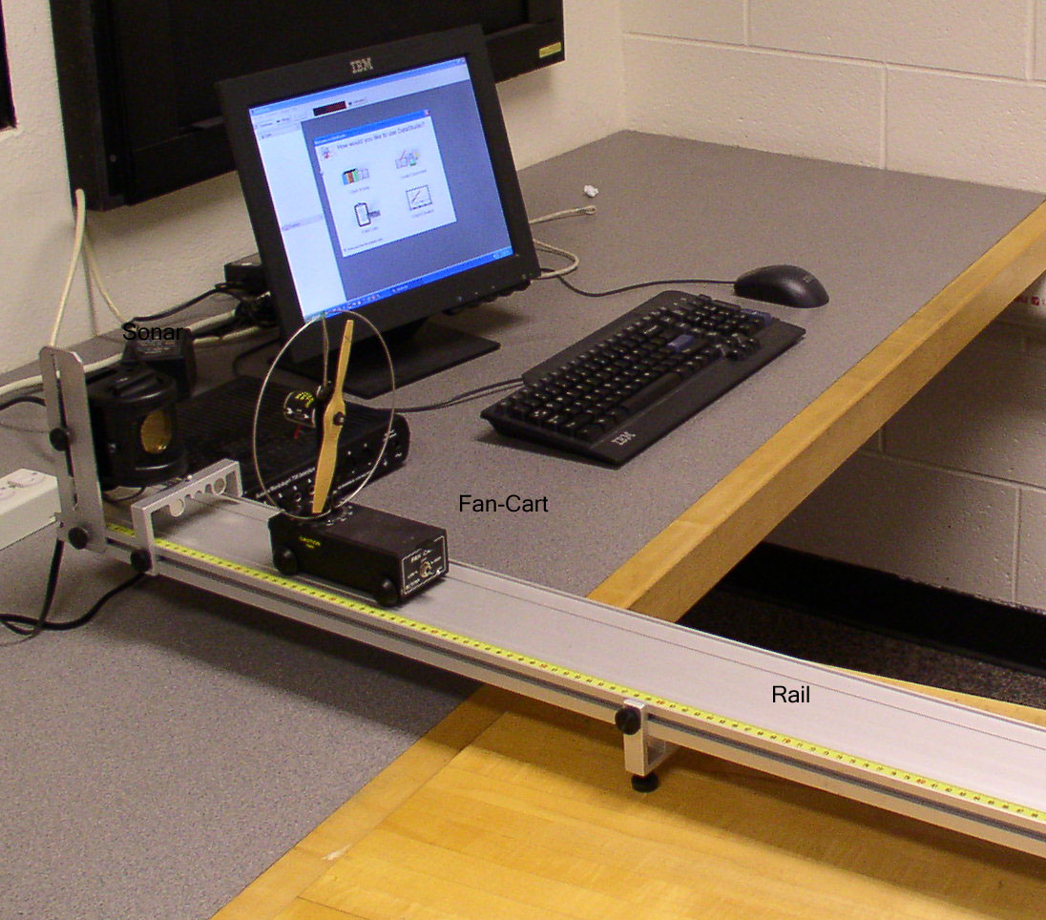

**1-D Force:**

The setup that we will use in this experiment is almost identical to the one we used above. It consists of a 2-meter long track (rail), a cart, and a sonar motion detector. We tie a light string to the cart, pass it over a pulley that is connected to the end of the rail opposite to the sonar, and hang a mass from the other end of it. As before, we will use the Capstone software to collect position versus time data for the moving cart.

**1-D Motion Procedure:**

**Part A – Constant Velocity**

1. Begin by adjusting the legs of your track in order to **level** it. You can tell whether your track is leveled or not by noting the motion of the cart. If the cart stays put, then the track is level.
2. To start taking data you need to activate the software:
   * *Double-click:* **Capstone**
   * *Click:* **Hardware Setup** (in the upper left corner)
   * *Scroll down and double-click on* **Motion Sensor** II (then close that window by clicking on Hardware Setup again)
   * *Double-click on* **Graph** *and then choose* **Position** *for the y-axis.*
   * *Click on the colored triangle in the toolbar to display more than one run at a time.*
3. Give the cart a gentle push away from the sonar and collect data by clicking on the **Start/Stop** button
4. Select the data points that seem to follow a straight line and fit a linear plot through them. *You can select the data by bringing the curser to the first data point and then* **click-and-drag** *the mouse over the rest of the data points. The selected points are then highlighted yellow. (To select another group of points click anywhere on the graph and your current selection will erase. Now you can select the desired group.) To fit a straight line, click on the* **Fit button** *and select* **Linear Fit.**
5. Repeat the above (3 followed by 4) for two other cart speeds. For one of these two runs push the cart at the motion sensor instead of away. You should now have three graphs two for the cart moving away from the motion sensor and one at the motion sensor.
6. For each lab partner print a copy of this graph. Write your name and the date of the experiment at the top of the page. Also on this page make a separate table for each of the three runs. In each table record the position and time coordinates for two data points on each straight line. From these data calculate the corresponding velocity values, by hand, and compare these with the slopes of the straight lines. Explain why the slope of the motion towards the motion sensor is “negative.”

**Part B – Constant Acceleration**

1. Now turn on the fan on the cart and collect data as the cart speeds **away from the sonar**. Be careful to keep your fingers away from the fans!
2. Select the points, but now choose a **Quadratic Fit** to them. (You should be able to explain the significance of these fits.) Print the graph and write a few sentences describing these resulting motions.
3. Repeat the above (7 followed by 8) for the fan **cart speeding toward the sonar**. Again fit the data and print out this page and write on it a short summary of the motion, answering the following questions:
   * In the position versus time graph: how does motion with constant speed appear? How do two such graphs, on the same plot, indicate the faster moving object? Which object is moving “forward” and which one “backward”? How does “slowing down” appear? How does “speeding up” appear? How does a “stop” appear? What is the significance of a parabolic position versus time graph? How can you tell the accelerating object is moving forward or backward? Finally, what was the maximum speed that your cart could reach with its fan turned on?

**1-D Force Procedure:**

1. Hang a 10 g hanging mass from the free end of the string and collect position versus time data for the accelerating cart, as you did in a previous part. Repeat this four more times and record the values of your acceleration in the Table 1 of the attached worksheet.
2. Repeat this (i.e. part 2) for 20, 30, 40, and 50 g hanging masses.
3. Weigh the cart and record this value in your worksheet. Also, estimate the uncertainty in your measured value of the cart’s mass.

**Analysis:**

(You can use a calculator or the Excel spreadsheet to analyze your data. Your instructor will give you a quick introduction to Excel if you are unfamiliar with its use.)

1. Calculate the average acceleration of the five trials for each of the hanging masses. Record these in your worksheet, under ****.
2. Calculate the standard deviation of the acceleration for each of the hanging masses and record these values in your worksheet in Table 1.
3. Copy the average acceleration (****) and standard deviation of the acceleration (****) from Table 1 as  in Table 2.

**Table 1 – measured acceleration of the cart for various masses**

|  |  |  |  |  |  |
| --- | --- | --- | --- | --- | --- |
| Trial | for m = 10g | for m = 20g | for m = 30g | for m = 40g | for m = 50g |
| 1 |  |  |  |  |  |
| 2 |  |  |  |  |  |
| 3 |  |  |  |  |  |
| 4 |  |  |  |  |  |
| 5 |  |  |  |  |  |
| Avg |  |  |  |  |  |
| St. Dev. |  |  |  |  |  |

Mass of Cart, M (kg) : _________________

1. Now, for each hanging mass calculate its dynamically determined acceleration, (****) along with the uncertainty (****) and enter these calculated values into Table 2. To determine the dynamic acceleration draw a free-body diagram and use Newton’s Second law motion to derive an expression for the acceleration of the cart in terms of the mass of the cart , the hanging mass, and the acceleration of gravity,******.

**Free-body diagram and derivation of dynamic acceleration**

**Table 2 – Comparisons of the kinematically and dynamically determined accelerations**

|  |  |  |
| --- | --- | --- |
| **m (g)** | **(m/s2)** | **(m/s2)** |
| 10 |  |  |
| 20 |  |  |
| 30 |  |  |
| 40 |  |  |
| 50 |  |  |

1. Do the results for and agree within experimental uncertainties?