The Ballistic Pendulum
Physics 110 Laboratory

Introduction:
In this experiment you will determine the muzzle velocity of a gun using three different methods. The first method consists of applying kinematics to determine the muzzle velocity of a ball fired horizontally from the tabletop by measuring the range of the ball and the height of the gun. In the second part of the experiment, the ball will be fired into the ballistic pendulum shown in Figure 1 and the muzzle velocity will be determined by measuring the angle through which the pendulum rises and applying conservation principles. Lastly, we will use an electronic photogate to determine the launch speed of the projectile
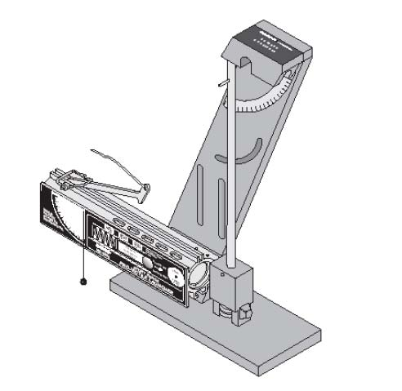
Figure 1: The ballistic pendulum.

The experiment
A. Determining Muzzle Velocity from Projectile Kinematics
- Clamp the ballistic pendulum near one end of the table with the launcher aimed away from the table and secure the pendulum up out of the path of the ball.
- Place the metal ball in the launcher and use the ramrod to cock the piston to medium range.
- Fire the gun and note where the ball lands.
- Tape a sheet of white paper to the floor at the point of impact and place a piece of carbon paper on top of it.
- Fire the gun ten times, making sure that marks are being made on your paper.
- Measure and record in a data table the distance from the point directly below the release point of the ball to each of your ten marks.
- Determine the average horizontal distance x, the ball travels. Also, calculate the standard deviation of your measurements and use this as the uncertainty, Δx, in your measurement of x. Record the result as x+Δx.
- Measure and record the vertical distance, y, the ball falls. Estimate the uncertainty in this measurement, Δy, and record your measurement as y +Δy.
- Use the expression you derived in Section 2.1 with the average value for x and the measured value for y to determine the muzzle velocity, v. Also, determine the uncertainty in v from the uncertainties in x and y and record the result as v+Δv.

B. Determining Muzzle Velocity Using the Ballistic Pendulum
- Load and set the launcher to the medium range.
- Return the pendulum to its vertical position and move the angle indicator to zero degrees.
- Fire the launcher and note the angle reached.
- Load the launcher, then set the angle indicator to an angle of 12º less than that reached in step 3. This will nearly eliminate the drag on the pendulum caused by the indicator, since the pendulum will only move the indicator the last few degrees.
- Fire the launcher and record the angle reached by the pendulum.
- Repeat steps 4 and 5 and record the angle each time to get a total of ten angle measurements.
- Determine the average angle. Also, calculate the average deviation of your measurements and use this as the uncertainty, Δθ, in your measurement of θ . Record the result as θ +Δθ .
- Remove the pendulum from the base by unscrewing and removing the pivot axle.
- Measure the mass of the pendulum and ball together, estimate the uncertainty, and record the result as M+ΔM.
- Measure the mass of the ball, estimate the uncertainty, and record the result as m +Δm.

- Determine the center of mass of the pendulum with the ball by balancing it on the edge of a ruler. Measure the distance from the pivot point to this balance point, estimate the uncertainty, and record it as Rcm +ΔRcm.
- Use the expression you derived in the Pre-Lab Exercies with the data you measured in this section to calculate the muzzle velocity of the launcher. Also, determine the uncertainty in v from the uncertainties of your measurements and record the result as v+ Δv.

C. Determining the Muzzle Velocity using Capstone and a Photogate timer.
1. Open Capstone, click hardware setup and under hardware setup choose photogate 1 flag.
2. After selecting photogate 1 flag, click on the blue cog in the lower right corner of the dialog box.
3. Set the flag width to the width of the ball, 25mm.
4. Close the dialog box and the hardware setup box.
5. Select table from the options on the right and choose speed (m/s) and time in gate (in ms) for the two tables.
6. Load the ball on the medium setting.
7. Click record and fire the ball through the photogate. You should have a measurement now of the launch speed of the ball.
8. Click stop recording and reload the ball in the launcher.
9. Repeat steps 7 and 8 a total of ten trials and average your values for the launch velocity of the ball.

Questions
- Do the values for the muzzle velocity determined using the three different methods agree to within experimental uncertainties? Calculate a percent difference.
- What sources of error are there in this experiment? How much do these errors affect your results?
- What percentage of the kinetic energy is lost in the collision between the ball and the pendulum? Would it be valid to assume that kinetic energy was conserved in the collision?
- How does the angle reached by the pendulum change if the ball is not caught by the pendulum? You may test this by turning the pendulum around so the ball strikes the back of the catcher. Is there more energy or less energy transferred to the pendulum?

Be sure to attach your derivations of the muzzle velocities and calculations to the end of this lab handout as well as the answers to these questions.

