Union College Spring 2022

Name ______________________ Partners: _____________________ ______________________

Physics 121 Makeup Lab
Measuring the Mobile Electron Density and Drift Speed Using the Hall Effect.

Introduction
The Hall Effect, discovered by Edwin Hall in 1879 while he was working on his doctoral degree, provides an experimental method for determining the sign of the charges in a current, the number density of charges in the current, and the drift speed of those charges.

Consider a current flowing in a thick conducting slab of width w which is located in a strong magnetic field in a direction perpendicular to both the direction of the current and the thick dimension of the conductor.
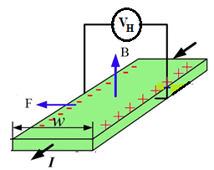
Figure 1: A current I flows out of the page through a thick conducting slab of width w and a magnetic field B is directed upwards, perpendicular to both the current and the width of the slab.

The charges in the current, moving at the drift speed, v_{d}, are influenced by the magnetic force,
${\vec{F}}_{mag}=q\vec{v}×\vec{B}$, and so are turned in a direction perpendicular to both the current and the magnetic field. A current could be due to positive charges moving in the direction of the conventional current, I, or to negative charges (i.e., electrons) moving in the opposite direction.

In Figure 1, the conventional current coming out of the page is due to electrons moving into the page. The electrons are turned toward the left side of the slab by the magnetic force. Positive charges moving in the direction of I would also be turned to the slab’s left side.

The displacement of the charges creates an electric field in the slab that applies an electric force on the charges in the opposite direction from the magnetic force. An equilibrium is reached, where
${\vec{F}}_{elec}+{\vec{F}}_{mag}=q\vec{E}+q\vec{v}×\vec{B}=0$. Or $\vec{E}=-\vec{v}×\vec{B}.$

Since the drift speed and the magnetic field are perpendicular, the equilibrium electric field is

$$E=v_{d}B$$

The potential difference across the width of the slab is then measured. This is called the “Hall Voltage”, denoted as V_{H}, and is given by
$V_{H}=Ew=v_{d}wB.$ (1)

For any given orientation of the volt-meter leads (e.g., V_{right} – V_{left}), the sign of the Hall voltage depends on whether the current is due to positive charges flowing in the direction of I or negative charges moving in the opposite direction. Hall discovered before the discovery of the electron by JJ Thomson in 1897, that the current is due to negative charges.

The magnitude of the Hall Voltage yields a measure of the drift speed of the charges in the current, via Equation 1. Once the drift speed is known, the equation relating current and drift speed, as given in Equation 2,
I = q n_{e} A v_{d}, (2)

yields a measure of the number density of the mobile charges.

In an ordinary conductor, the Hall Effect is, actually, a very difficult measurement to make. To make this lab more feasible, we will measure the Hall Voltage not in a conductor, but in a doped semiconductor. You don’t need to know what that actually means other than the number density of electrons will be much smaller than in conductors. To achieve the same current, then, the electrons will have a much larger drift speed than you learned in class.

Lab Equipment:
The Hall Effect equipment and setup are displayed in Figure 2. The equipment should already be setup and connected to the computer.

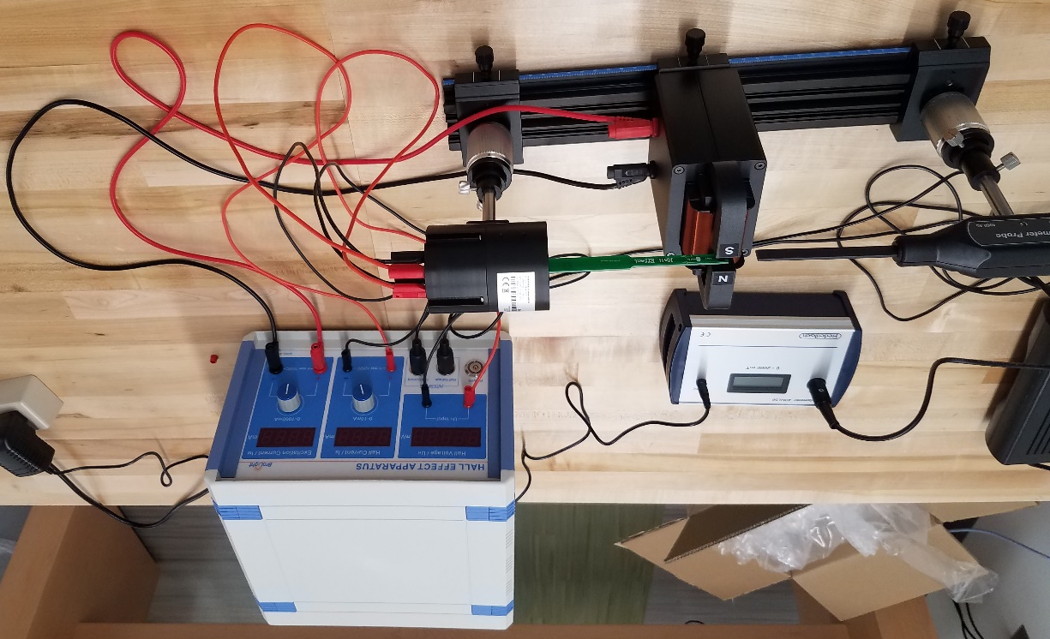
Figure 2: The Hall Effect setup.

The equipment includes an electromagnet, with “N” and “S” labels, a magnetic field sensor which can be inserted between the poles of the magnet, and a Hall Effect probe which also gets inserted between the poles of the magnet (but not at the same time as the magnetic field sensor).

The Hall Effect probe contains the doped semiconductor strip in which the current runs, and across which the Hall Voltage is measured. The width of the strip, across which the Hall Voltage is measured is w = 2.3 mm. The other dimension of the strip perpendicular to the current is 1.2 mm.

Record these values of the widths of the semi-conductor strip in your data table.

Get familiar with the adjustments: The “Hall Voltage” and “Hall Current” are displayed in the first two windows of the blue “Hall Effect Apparatus” box. The magnetic field strength is displayed on the silver “Tesla-meter” box and is controlled by the “Excitation Current,” which is adjusted with the right-most knob on the “Hall Effect Apparatus” box.

Instructions
1. Calibrating the Magnet
- In Excel create a column with “Excitation Current (mA)” and another with “Magnetic Field Strength (mT)”.
- In the Excitation Current column, enter values from 50 to 250 mA, in steps of 50 mA.
- Make sure the Hall Current is set to zero.
- Move the magnetic field sensor into the center of the magnet.
- Set the Excitation Current to 50 mA and read the magnetic field strength on the Teslameter and record both.
- Repeat for all the currents up to 250 mA.

2. Obtaining Data
- Create another column with Hall Voltage (mV),
- Move the Magnetic Field sensor out of the magnet and move the hall Effect Probe in.
- Set the Hall Current to 5 mA
- Set the Excitation Current to 50 mA and read and record the Hall Voltage. Be sure to take note of the sign.
- Obtain measures of the Hall Voltage for all the previous settings of Excitation Current up to 500 mA
- Set the Excitation Current back to 0, change the Hall Current to 7 mA and obtain data of Hall voltage for the same set of Excitation Current values.
- Repeat for a Hall Current of 9 mA.

Analysis:
1. Examine the schematic of the Hall Effect probe in Figure 3 and from your setup, determine the direction of the magnetic field in the figure.
(a) Based on the magnetic force equation, in which direction are the mobile charges turned in the schematic (to the left or right side)?
(b) Based on the sign of your Hall Voltage, on which side (left or right)?
(c) Are the current charge carriers positive or negative?
Figure 3: Schematic of the Hall Effect Probe showing the direction of the conventional current (I_{S}) and the orientation of the Hall Voltage (U_{H}) leads.

2. Based on Equation (1), make a plot of your data to infer the drift speed of the charges in the current in the semiconductor for each of the three Hall current settings. Be sure to use regression analysis to get an uncertainty in the slope.
3. How does the drift speed depend on current? Make another graph with drift speed on the y-axis and current on the x-axis. From the slope of the graph (use regression analysis) and the relation between current and drift speed given in Equation 2, infer the number density of mobile charges in the semi-conductor. In Equation 2, where A is the cross-sectional area semi-conducting strip, i.e., 2.3 mm × 1.2 mm.
4. Consider and discuss making these types of measurements in typical metal wires, where the drift speeds and smaller. What makes this more difficult to measure and what improvements in the equipment would be needed to make the measurements feasible?

