Union College Spring 2021
Physics 120: Lab 6
The Ballistic Pendulum

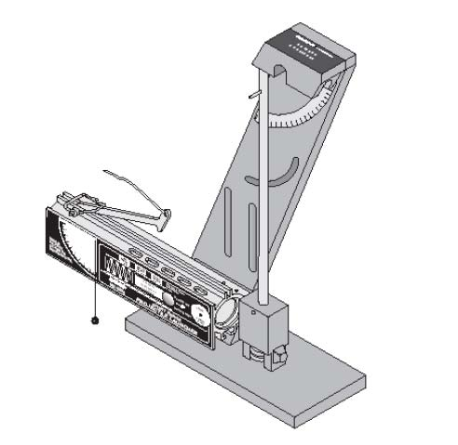
In this experiment you will determine the “muzzle speed” of a ball launcher using a classic device called a ballistic pendulum (shown in Figure 1). Before the invention of radar, armies would measure the speed of bullets by firing them into a pendulum and measuring how high the pendulum swung. The calculation requires analysis of the collision between the ball and pendulum, followed by the conservation of energy in the swing of the pendulum.

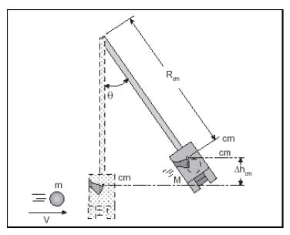

Figure 1: The ballistic pendulum Figure 2: A ball of mass, m, and speed, apparatus v, is caught by the pendulum, which swings up to an angle θ.

Derivation of the Equation for Muzzle Speed
A ball fired with speed, v, gets trapped in a catch at the end of the pendulum, which then swings upward to some maximum angle, θ, as shown in Figures 1 and 2. Apply the proper principles in the two events—the completely inelastic collision between ball and pendulum and the swing upward of the pendulum with ball--to derive an expression for v in terms of:
- the mass of the ball, m,
- the mass of the pendulum, M,
- the length of the pendulum pivot point to the center of mass, R_{com},
- the strength of the gravitational field, g,
- and the maximum angle of the pendulum’s swing, θ.

The Experiment
1. Remove the pendulum and obtain and record the masses of the ball and pendulum, and estimate the uncertainties.

2. Determine the center of mass of the pendulum with the ball in it by finding the point where it best balances on the edge of a ruler. Measure the distance from the pivot point to this balance point, including your estimate of the uncertainty.

3. Reattach the pendulum, insert the ball into the launcher, and cock it to long range.

4. Let the pendulum hang at its vertical position and move the angle indicator to zero degrees. Fire the launcher and note and record the angle reached.

5. Reload the launcher and set the angle indicator to an angle of 5º less than that reached in step 4. This will nearly eliminate the drag on the pendulum caused by the angle indicator, since the pendulum will only move the indicator the last few degrees.

6. Fire the launcher and record the angle reached by the pendulum. Try to estimate the angle to the nearest 1/2 degree.

7. Repeat steps 5 and 6, recording the angle each time, completing 10 trials.

8. Input the expression you derived in Section 2 into Excel to calculate the muzzle speed of the launcher for each trial. Calculate the average v and uncertainty.

