Magnetic Dipole Moment of a Neodymium Magnet
The Experiment
The photograph below shows the experimental setup. A compass is mounted at the center of a pair of Helmholtz coils. A small magnet is mounted on the end of a rod attached to a slider. By pushing the slider, the magnet can be brought closer to or farther from the compass. The slider is oriented so that the magnet moves along the axis of the coils. The approaching magnet causes the compass to deflect, but that deflection can be cancelled by running a current through the loop. When the current is just enough to return the compass to its original it must be creating a field just equal and opposite to the field from the magnet. The formula for the field at the center of the Helmholtz coils is
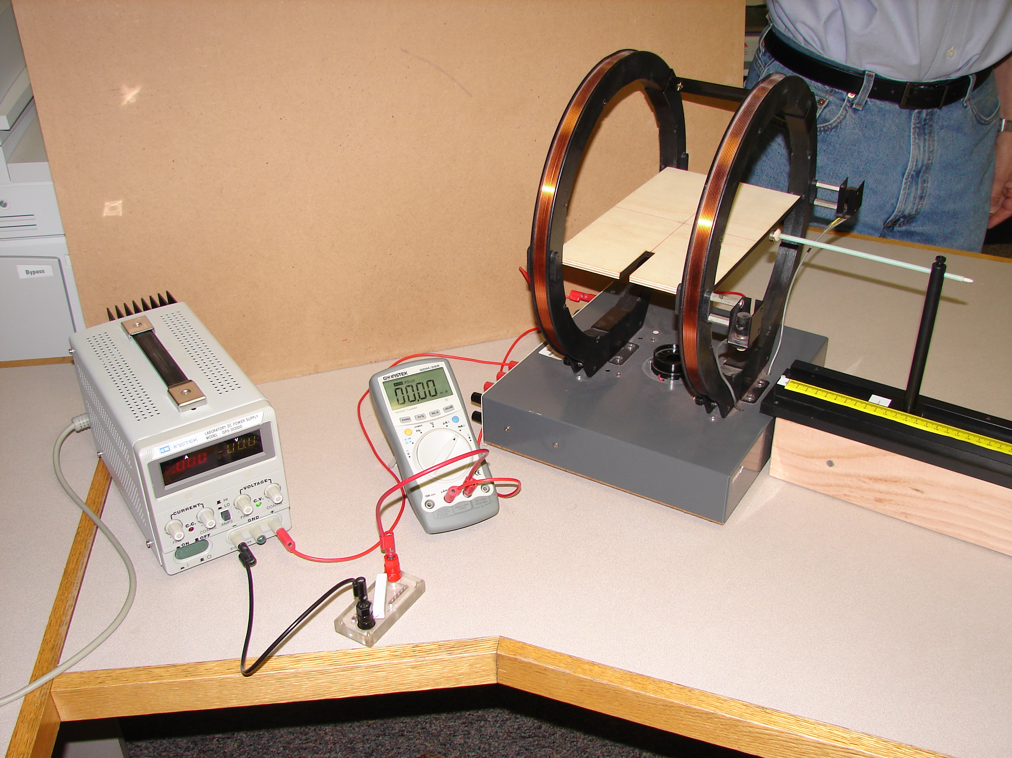
$B=\left(7.8×{10}^{-4}\frac{T}{A}\right)I$
1. Make sure that the orientation of the equipment is correct. With the magnet present, but the compass removed, make sure that pushing the slider causes the rod to move along the axis of the circular loop. Also check that the reading on the scale accurately measures the distance between the magnet and the center of the coils.
2. With the magnet removed (and brought several meters away), mount the compass at the center of the wire loop. Orient the N-S markings of the compass parallel to the plane of the coils, and orient the E-W markings along the axis of the coils.
3. Rotate the entire apparatus so that the compass needle points along the N-S line. Now replace the magnet on the end of the rod and move the slider to about 20.0 cm. You should note that the compass has deflected. Try running current through the loop to cancel the magnetic field from the magnet. You may find that the current adds to the field instead of cancelling it. If that is the case, just reverse the leads to the power supply so that the current is in the opposite direction.
4. Now take some data. Find the size of the cancelling current and its magnetic field for various readings of the slider. You should have distances ranging from about 30 cm to 10 cm. Start with the larger distances and as you get closer to the center of the loop reduce the increments of distance you make at each step. Graph your data. You should have graphs of $B vs. r$ and $\ln\left(B\right) vs. ln⁡(r)$. As a result of these graphs you should find that
$$B=Kr^{α}$$
And you should have experimental values for K and $α$. Is your result consistent with a $1/r^{3}$law for dipoles?
Analysis
1. For a magnet that is small in size, your textbook says that the magnetic field along its axis will be given approximately by
$B≈\frac{μ_{0}}{4π}\frac{2μ}{r^{3}}$,
Where $μ$ is called the magnetic dipole moment of the magnet. Based on your data, what the value of $μ$ for your magnet?

2. The dipole moment of a magnet has its origins in the motion if the electrons in the material. Electrons orbits a nucleus, for example, act somewhat like a current going round a tiny circular circuit. For a variety of reasons (mostly quantum mechanical) the dipole moment of an atom is rarely much bigger than about ${10}^{-23}A∙m^{2}$. In most materials these atomic-size dipole moments are aligned every which way and tend to cancel. But in permanent magnets, there are forces between the atoms that tend to align the dipole moments in the same direction so that they add up. Still the alignment is not perfect, and it is difficult to see how a magnet could have a dipole moment much bigger than ${N∙10}^{-23}A∙m^{2}$, where N is the number of atoms in the magnet. Even though they it is called a neodymium magnet, the magnet you are using is mostly made of iron. Find the mass of your magnet, estimate the number of iron atoms that would make up that mass Then calculate the factor f in
$μ=fN∙{10}^{-23}A∙m^{2}$

Does your result suggest that the dipole moments are strongly or weakly aligned?

3. Another way to analyze the magnetic field of a magnet is to compare it with the field that would be generated by a similarly sized current loop. The magnetic field along the axis of a circular current loop is given by

$B=\frac{μ_{0}}{4π}\frac{2πR^{2}I}{{\left(z^{2}+R^{2}\right)}^{3/2}}$,

Where R is the radius of the loop and z is the distance along the axis from the center of the loop.

If $z≫R$, as it is in your experiment, this is approximately the same as
${B≈\frac{μ_{0}}{4π}\frac{2πR^{2}I}{z^{3}}}^{}$,

Now measure the radius of your magnet and find the current I that would be needed to produce the same magnetic field.

